

2016–17
ANNUAL REPORT

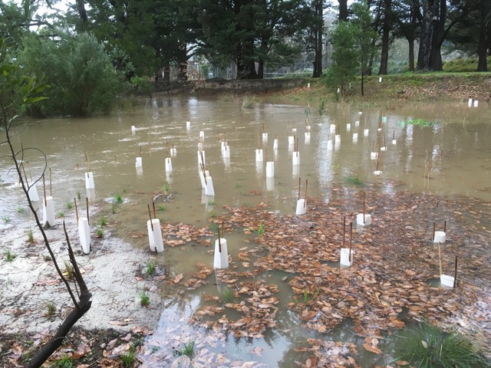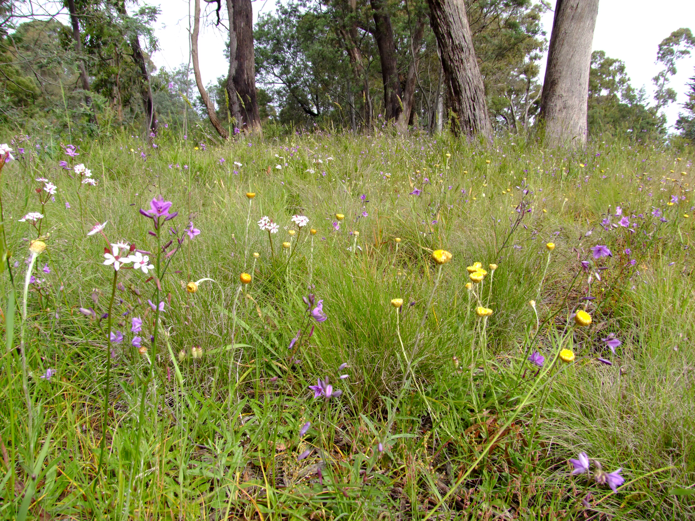

ANNUAL GENERAL MEETING

To be held at Woodend Neighbourhood House, Forest St, Woodend,
Tuesday 29 August 2017, 7:00 pm

AGENDA

- 7:00 pm President’s welcome – Kate Daniel
- Apologies
- Minutes of previous AGM
- President’s report
- Election of Committee Members – Susan Carroll
- Vote of thanks to retiring Office Bearers – Susan Carroll
- Meeting close
- 7:30 pm Guest speaker – Greg Boldiston, ‘Hidden jewels of our forests’
- Supper

MINUTES of the Annual General Meeting of
Woodend Landcare 2016

Held on 23 July 2016, 1:30 pm at Woodend Neighbourhood House

- President’s Welcome & Report
Krista Patterson-Majoor called to order the AGM of Woodend Landcare at 1335 on July 23, 2016 at Woodend Neighbourhood House. The Dja Dja Wurrung were formally acknowledged as the traditional owners of the local region.
Krista reviewed the activities and achievements of the past year, including several projects and educational activities, and directed attendees to refer to the annual report for more details. Krista outlined a goal for members to reinvigorate the committee with new people.
Particular thanks were given to member Peter Yates, who is an important team member in our projects, and to committee members who were standing down at the AGM: Bob Sullivan, Barry Clarke, John Newell and Ken Lawford from the Thursday Crew and Jo Clancy.
Jo Clancy, Barry Clarke and John Newell each gave a heartfelt response to the audience, relating their achievements and honour to have served the community.
- Roll call
The following persons were present: D. Bower, S. Carroll, J. Clancy, B. Clarke, D. Dalgleish, K. Daniel, C. Griffith, D. Gossip, L. Healy, M. Horner, S. Marriott, J. Newell, K. Patterson-Majoor, P. Rice, N. Thomson, L. Vale, A. Van Dam, P. Yates.
- Apologies
J. Anderson, N. Aplin, R. Fink, C. Holmes, K. Lawford, N. Middleton, R. Perich and B. Sullivan.
- Approval of minutes from last AGM
The minutes from the last AGM were presented in the Annual Report. The minutes were approved as written (moved K. Patterson-Majoor, seconded J. Clancy).
- Election of Committee Members – Susan Carroll
Susan declared all positions vacant and gave a vote of thanks to the retiring committee. As there were no competing nominations, all nominees were elected to the new committee, as follows:
- President: K. Patterson-Majoor
- Vice-president: D. Bower
- Secretary: L. Vale
- Treasurer: P. Rice
- Working Bee Coordinator: D. Gossip
- General Committee: D. Dalgleish, K. Daniel & A. Van Dam.

- Adjournment
Krista Patterson-Majoor adjourned the AGM at 13:50. The attendees then discussed the Lake Earnshaw plans designed by Pene Rice, and listened to a talk by Linda Healy on the Macedon Ranges Koala Project.
Minutes submitted by: L. Vale (Hon Sec)

PRESIDENT’S REPORT 2016–17

Woodend Landcare’s activities this year have been varied and successful. We’ve held 9 monthly working bees (from Ruby Mackenzie Park, via the Children’s Park and Envirofund Site to Slatey Creek Reserve) and close to 50 Thursday Crew musters, centering on Quarry and Bawden roads, Lake Earnshaw and Buffalo Oval.

We bought and were trained in the use of a defibrillator and it is on-site at all weekly and monthly working bees and events. We shared a stall at the Macedon Ranges Sustainability Festival and we hosted a dozen DELWP staff at a working bee at Quarry Rd just before Christmas. We remain active members of the Upper Campaspe Landcare Network, a collection of 16 local Landcare groups from Trentham to Pastoria and Newham. Member groups are working in small clusters to create and maintain biolinks, along waterways, reserves and on private property.

The year’s $6650 DELWP grant has almost been acquitted. This Community Action Volunteer Grant is the very best type of grant: a big proportion allowed to be spent on contractor weed control (great work from Indig-We-Do) and a much smaller part towards revegetation. We also benefited from a 7-man Landmate corrections crew from Loddon prison, who worked in wretched weather for three days clearing woody weeds on the north side of the creek near Campaspe Drive. They were terrific workers and came with their own gear, trailer and supervisor. I’ve only positive things to say about their contribution, which was free as part of this DELWP funded project.

Blood, sweat and tears went into the creation of an extensive plant list recommending indigenous species for Woodend sites, now available on the blog. Thanks to Adam Barber, David Gossip,
Krista Patterson-Majoor and Peter Yates for putting this together.

Quarry Rd Rail Reserve was the centre of much attention in spring after good rain led to an explosion of grasses and wildflowers and we commissioned botanist Karl Just to do a flora report (see blog). He identified 81 indigenous species, including ‘groundflora of exceptional quality and diversity’. We also had site visits from natural resource managers from VLine and MRSC in a bid to protect some of the best areas (near Washington Lane). We’re still working on getting some VLine signage but mowing guidelines have been updated and are available on the blog. Essentially, as custodians of native remnant patches, we must be sensitive and minimalist: don’t mow too low, too early or too often.

The Trees for Mum planting was funded by the DELWP grant this year, with Lake Earnshaw the site. Our various subgroups of Slatey Creek, MRIMAG, Thursday Crew and Trees for Mum remain active and dynamic. You’ll find more detail on their activities in their individual reports.

Still to come in 2017 is a bit more weed control, a bit more planting and a DIY trailer makeover. Thank you to all current and past committee members for their enthusiasm and willingness to attend meetings and deal with emails, as well as wield baking trays, power tools or dabbers at working bees. You’re a wonderful group of people.

I acknowledge with thanks support from MRSC and NCCMA, as well as the UCLN.

Kate Daniel
August 2017

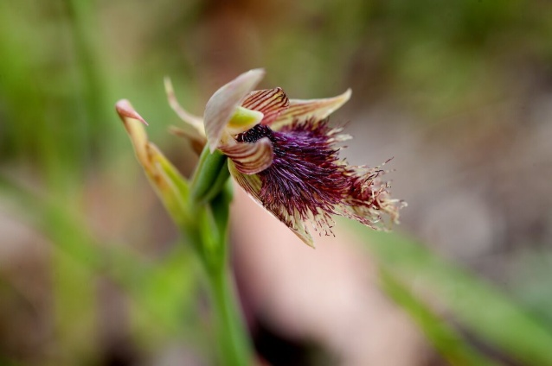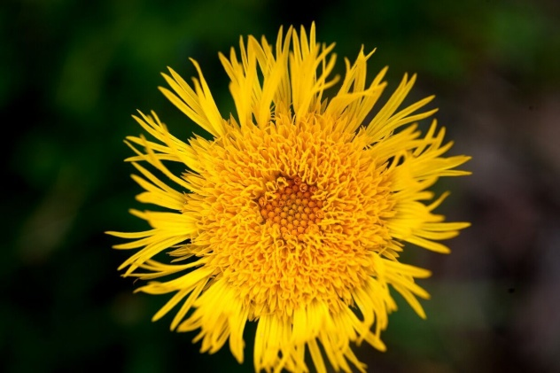

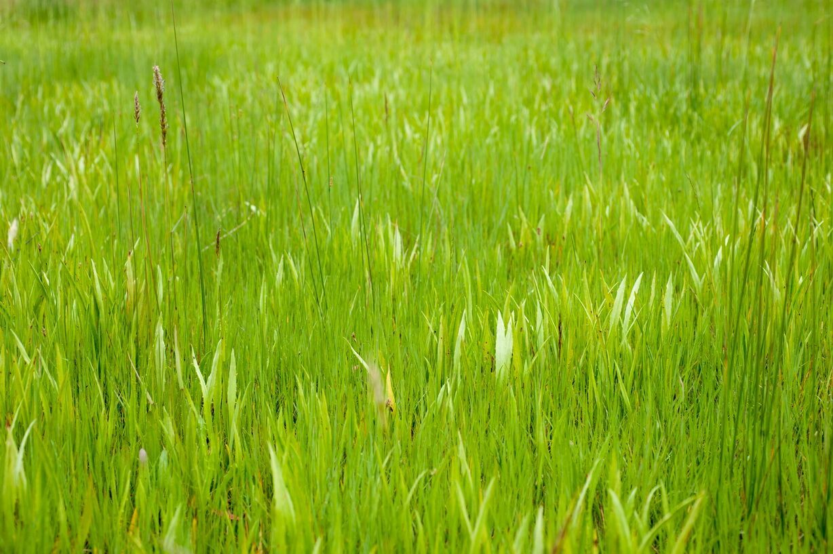

TREASURER’S REPORT 2016–17

This has been a low-key year in terms of financial activity for Woodend Landcare. Through various grants and donations we have had just under $10,000 in income. Thank you to the following organisations for their support:
Community Action Volunteer Grant (DELWP) from the Victorian Government $6,650
Macedon Ranges Council with $800 in funding for MRIMAG and $800 for General Operating expenses.
North Central Catchment Management Authority $500.

Major expenses for the year were:
A defibrillator, including training ($3,915)
Trees for Mum planting day ($2,364)
Contracted willow and other woody weed removal along the Five Mile Creek ($2,495)

Membership numbers have stagnated over the last couple of years with numbers as follows:
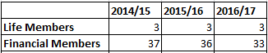
Membership fees remain at $20 per year. Membership is important to Woodend Landcare to cover our administrative expenses and we appreciate our members’ on-going support.

Finally I’d like to thank Kate Daniel for her assistance with my role as Treasurer.

Balance sheet as at 30 June 2017
1 Total group funds
Opening balance (1/7/16) operating account 14,877.87
Total opening balance (1/7/16) $14,877.87

Income 2016/17 $ 9,677.27
Expenses 2016/17 $12,913.01

Closing balance (30/6/17) operating account 11,642.13
Total closing balance (30/6/17) $11,642.13

2 Current committed funds
Thursday Crew | $2,740.66
MRIMAG | $1,760.53
Slatey Creek | $ 223.07
Machinery | $ 166.26
DELWP (CAV Grant) | $1375.56
Total Committed Funds | $6,266.08

3. Net funds available $5,376.05
Income and Expenditure Statement

Income
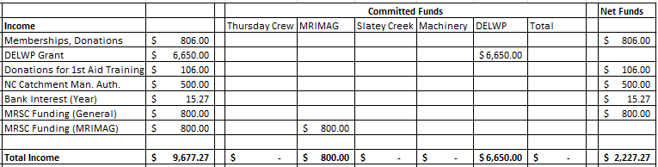

Expenses
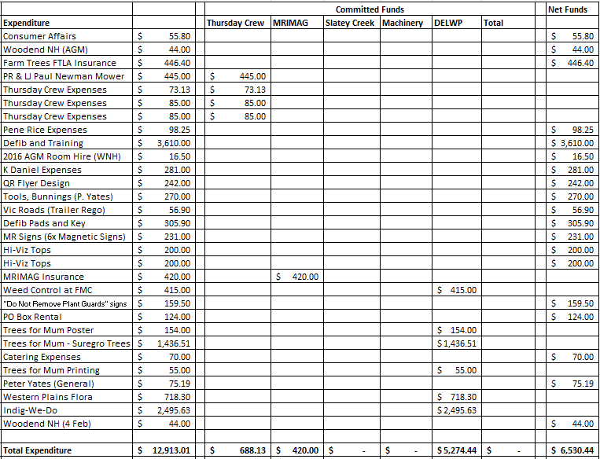

Neil Thomson
August 2017

SLATEY CREEK BLACK GUM RESERVE 2016–17

A fairly quiet year at Slatey Creek this year. Our annual group working bee was held in August 2016. Three quarters of the reserve was cleared of young emerging woody weeds such as blackberry, gorse and broom and the stumps were poisoned. The whole reserve was also checked for rubbish.

A very wet winter and spring in 2016 saw the creek near the top of its banks on numerous occasions. It is pleasing to be able to say there was minimal further erosion to the banks in a couple of spots that have been heavily planted by Landcare to prevent this. Most of our other past plantings at the reserve are continuing to thrive.

I continue to regularly check the reserve for any problems and am always on the lookout for new weed outbreaks. For example I discovered a small patch of angled onion weed for the first time which was probably washed down in previous floods. I have removed the bulbs by hand and will check the area again this spring.

The next group working bee will in autumn 2018 with hawthorn seedlings a top priority to remove.

David Gossip
August 2017

 MACEDON RANGES INDIAN MYNA ACTION GROUP 2016–17

MRIMAG has now been running for four years. It is currently operating across nine towns in the Macedon Ranges (Woodend, Newham, Kyneton, Malmsbury, Gisborne, Macedon, Lancefield, Riddells Creek and Romsey) with nearly 250 traps and trappers spread across the program.

Total catch numbers to date stand at over 5000 birds, with monthly catch numbers declining across the board. While this is a good sign, our work is still far from done: in May alone, 72 birds were caught in Gisborne and 40 in Woodend.

This year the group participated in a research project run by the Australian Museum into the DNA of Australian mynas and their dispersal. Several trappers contributed carcasses from their towns to be part of the research. Information will be made available to members as the research continues.

It’s about this time of year mynas will start to pair up and begin their nest building. Trappers are encouraged to dust their traps off and get busy trapping the spring fledglings. Don’t forget to keep those chook bins and compost bays covered to deter mynas at your place.

Ron Fink and Kate Daniel
August 2017
THURSDAY CREW 2016–17

The past year has not been without difficulties, with some of our elderly and more experienced members retiring due to health issues. However the Crew were fortuitous to somehow gain the services of the indefatigable Debbie Gamble and Rose Perich, who have been instrumental in ensuring our work continues.

This year, besides the Lake Earnshaw environs, we attempted to quell the proliferation of gorse, broom and blackberry along Quarry Rd. To the north side of the railway line from the Medical Centre to Wood St, similar applications were applied.

We also assisted in the preparations and plantings at Glen Osmond Special Kids project, under the guidance of the lovely Ro Wilkinson. Long may our association continue.

The Black Gum reserve on Bawden Rd was another location we got stuck into, endeavouring to control the blackberries. We were also active on the Heritage Walk, responsible for tidying up that popular public area. The scout plantings at the billabong and St Ambrose plantings were also attacked, removing weeds which were curtailing growth.

At the request of council, we were asked to eradicate the blackberries behind the waterway to the west of Peter Godden Dve. After our first size-up of the task – massive – a mutiny almost broke out but was subdued with beer and wine.

Special thanks to Brian Christie for his continual upkeep of the Rotary track and the patch at the western end of Urquhart St. Also a big thanks to Ken Lawford and Paul Newman for their diligence in the Quarry Road area. It’s been great to have our mentor John Newell back with us again and we all benefit from his vast experience.

Thanks to the Woodend Landcare committee, especially to Kate and Neil for their ongoing support.

Dave Bower
August 2017
TREES FOR MUM 2016–17

We had perfect conditions for our 2017 Trees for Mum planting day on Mother’s Day.

A constant stream of eager planters saw 400 indigenous trees, shrubs and grasses planted near Lake Earnshaw.

Over the past few years the Thursday Crew team has been hard at work restoring this historic site from an overgrown mass of blackberries to the tranquil open space it is today, which made it the perfect choice for Trees for Mum 2017.

The trees and shrubs planted were a range of natives suitable for the climate and location. These were combined with grasses providing native understorey to improve the habitat at Lake Earnshaw.

Huge thanks to all who came along to plant a living legacy for a loved one and to the incredible Woodland Landcare team of volunteers for making the morning the success it was.

Angela Van Dam
August 2017

